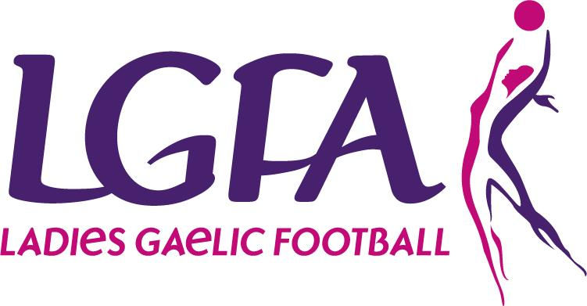
Ladies Gaelic Football Association
Full Membership Application Form

Name:_______________________________________________________________________

Address:_____________________________________________________________________

Date of Birth: _____________________________Phone Number: _______________________

Email (If available): ____________________________________________________________

I hereby apply to:________Charlestown LGFA______ Club (“the Club”) for Membership of the Club and Membership of The Ladies Gaelic Football Association (“LGFA”)

I subscribe to and undertake to further the aims and objectives of the Club and of The Ladies Gaelic Football Association and to abide by its Rules.

I attach herewith the appropriate membership fee as determined by the above Club.

- Should any of this information change within the year, the onus is on the member to inform the club.
- We/I understand the personal data on this form will be used by the club and the LGFA for the contractual purpose of registering (or re-registering) and maintaining my membership
- We/I understand that the applicant’s Personal Data will also be used for administrative purposes to maintain their membership including club and team administration, registrations, teamsheets, referee reports, disciplinary matters, injury reports, transfers, sanctions, permits and for statistical purposes.
- We/I understand that if I do not provide my personal data my membership cannot be registered with the club and the LGFA.
- We/I understand that my contact information may be used to provide me with updates regarding legitimate club and LGFA activities.

We/I understand my rights under Data Protection legislation, as outlined on the reverse of this form

Signed____________________________ (Parent/Guardian/Member) Date: __________________________
PRINT NAME: ____________________________________

DATA PROTECTION/GDPR:
I have read the important Data Protection information below and have given my consent, by ticking the boxes and signing below, for my information to be used as follows:

(Please tick as appropriate)

(1) To provide me with updates regarding Club activities such as matches, meetings and club events

(2) To provide me with details of Club fundraising activities including Lotto, social occasions, ticket sales etc.

(3) I am aware that my photograph or video image may be taken whilst attending or participating in games or activities connected with the LGFA and I consent to it being used by the LGFA for items like match programmes, year books, match reports, event reports or on websites or social media channels associated with the LGFA.

(4) To contact me in relation to volunteering opportunities at LGFA events and activities

I understand that I can withdraw my consent at any time by writing to the [Charlestown Club Secretary or the LGFA].
I understand my rights under Data Protection legislation, as outlined on the reverse of this form

Signed____________________________ (Parent/Guardian/Member) Date: __________________________
PRINT NAME: ____________________________________

CODE OF BEHAVIOUR:
By becoming a club member, you agree to abide by the Code of Behaviour and to other policies, codes and procedures of the Club. If your child is underage, a parent must agree to adhere to this Code of Behaviour alongside their child. It is your responsibility to ensure you read this policy document in full prior to becoming a full member which is available via https://ladiesgaelic.ie/lgfa-hub/clubs/child-welfare-protection/code-of-behaviour/ . A copy of this document is available via your club secretary.

Signed____________________________ (Parent/Guardian/Member) Date: __________________________
PRINT NAME: ____________________________________

MEDICAL HISTORY:
Please outline any medical information (i.e. ailments, allergies, previous or existing conditions, medications etc.) which may impact on your health or welfare while participating in our activities. Please provide your explicit consent to providing this medical information by signing below your declaration.
________________________________________________________________________________________________________________________________________________________________________________________________________________________________________________________________________________________________________________________________________________________________________________________________________
- I consent to the processing of the personal medical data as outlined above for the purpose of administering medical assistance to my child if required.
- In the event of illness/injury, I give permission for medical treatment to be administered by a nominated first aider, or by suitably qualified medical practitioners.
- If I cannot be contacted and my child requires emergency hospital treatment, I authorise a qualified medical practitioner to provide emergency treatment or medication.

Signed____________________________ (Parent/Guardian/Member) Date: __________________________
PRINT NAME: ____________________________________

IMPORTANT NOTIFICATION
The following privacy information is being provided to you as outlined in the General Data Protection Regulation. It is intended to inform you of how the personal information provided on this form will be used, by whom and for what purposes. If you are unclear on any aspect of this form, or want any further information, please contact the LGFA’s Data Protection Officer on 01 8363156 or dataprotection@lgfa.ie.

Privacy Notice:
The information requested in this form is for the sole purpose of processing your membership status. Staff from the Ladies Gaelic Football Association (LGFA) will process the information provided. The legal basis for processing this membership is for the performance of a contract. The legal basis for items (a) - (d) is “contract”. The legal basis for items (e) and (f) is “legitimate interest”. Your personal data will be stored on the LGFA Membership Database which is provided by Cumann Lúthchleas Gael for the purposes of processing and archiving only. A third party contract is in place between the LGFA and Cumann Luthchleas Gael to ensure the safe and legal processing of membership information. The information will be retained for the duration of your membership and for 100 years thereafter. The LGFA retain the right to extent this timeframe for archiving purposes. This is purely to secure the history of our game and to ensure that your time and dedication to our sport is always valued and never forgotten.

Who is the data controller?
The club and the LGFA are joint data controllers of the personal data and contact details for the club are as follows [Please insert: Charlestown LGFA, Lowpark, Charlestown, Co Mayo 085-7273315 charlestown.mayo@lgfa.ie ].

Who is the Data Protection Officer for the LGFA and the club?
The LGFA Data Protection Officer is Paula Prunty. You can contact our Data Protection Officer at dataprotection@lgfa.ie or 01 8363156 if you have any questions or wish to make any request in relation to your personal data.

What is the purpose of processing my Personal Data?
The purpose for processing your personal data is that it is necessary for the performance of a contract in order to register and maintain your membership with the club and the LGFA. The purpose is also to keep you informed of club and LGFA events and activities as a member of the association.

Will anyone else receive a copy of my Personal Data?
Your personal data can be accessed only by appropriate members of the County boards, Provincial boards and National Administrative function. This will be done in accordance with our data protection policy only.
In the event of an injury claim, details of your claim which will include your personal data will be passed to the LGFA’s Injury Fund Administrator.

Where is your Personal Data stored?
Your data will be stored electronically on the LGFA membership database which is provided by Cumann Luthcleas Gael, Croke Park, Jones Road, Dublin 3.

How long will your Personal Data be stored for?
Your personal data will be held for as long as it is necessary and it has a purpose. This will vary depending on your club and their archiving needs. Please speak to your club for their specific membership retention policy. The LGFA retention period for membership data is outlined in the privacy notice above.

How can I obtain a copy of the Personal Data held by the Club/LGFA?
You have the right to request a copy of all of your personal data and can do so by contacting us.

What are my privacy rights relating to my Personal Data?
You have the right to request your personal data be updated, rectified, or deleted. You have the right to object to your personal data being processed - You can do so by contacting us.

Where can I get further information?
Further information regarding your rights can be obtained through the Office of the Data Protection Commissioner, 21 Fitzwilliam Square, Dublin 2. D02 RD28, or on the website www.dataprotection.ie

How do I make a complaint or report a breach?
Should you wish to make a complaint or report a breach under in relation to your personal data, you can do so by contacting your club representative or the LGFA Data Protection Officer at dataprotection@lgfa.ie or 01 8363156.

